HEALTH RECORD SYSTEM

FOR

CENTRAL UNIVERSITY OF PUNJAB, BATHINDA

#### Submitted By

**Thotakura Bala Krishna (17mtcysc04)**

#### Under the guidance of

### Dr. Amandeep Kaur

ASSOCIATE PROFESSOR

DEPARTMENT OF COMPUTER SCIENCE AND TECHNOLOGY

CENTRAL UNIVERSITY OF PUNJAB, BATHINDA - 151001

#### Dated-

#### Signature of Supervisor-

**ABSTRACT**

This is a project report on “**Health Record System**”. During the making/developing of this project we explored new ideas and functionality behind the working of the software used. This project is the output of my planning, schedule, programming skill and the hard work, and this report reflects the steps taken at various levels of programming skill, planning and schedule. I have learnt a lot during this project and liked the improvement in our testing skills and deep concept related to these kinds of projects.

My project is “Teacher Record System”. This project can be very helpful for maintaining the record of faculty members of computer science department. The main need of making this e- record system is to overcome the problems arises due to manual record or the record on papers. This project will definitely solve all such problems.

**PREFACE**

## Learning comes from doing. To learn something, one has to go through Practical conditions. Recognizing this fact, the University has made it essential for students of **Computer Science and Technology Department** to undergo the technical projects in the 3rd semester of M.Tech. During this period, the student learns how to implement the theoretical knowledge into practical life, in our day to day life. During this period, an effort was made to understand **Teacher Record System** and to finish the project work assigned to us. This report lays special emphasis on the operational work, tasks and projects carried out.

**Contents**

1. INTRODUCTION 4

2. OBJECTIVE 4

3. REQUIREMENTS 4

4. COMPONENTS OF THE PROJECT 5

5. MODULES 7

6. USE CASE DIAGRAM 10

7. FLOW CHART 11

8. SOURCE CODE 12

9. DATABASE TABLES 12

10. TESTING 13

11. ADVANTAGES 14

# INTRODUCTION

Today, Technology has grown in ways we never could've imagined and has an impact on just about every area of our everyday lives. No generation has felt the impact of the technological advances like this generation. Technology practically runs our lives, with apps and websites for everything imaginable, even some accessible to young children. Each and every member of society, regardless of age, is now connected to the world around us because of technology.

So, the old paper based record system is replaced by electronic record management system. This project is about the Health record maintained electronically. This project will keep record of students, teachers, dependents personal information and previous medications. So that everyone can view their medical history at any given time, Doctor can also view previous medication given to patient before giving new medication. The database can store the large no. of health records and if it is managed properly then it will not be difficult to access the data in possibly short time.

# OBJECTIVE

The main objective of this project is to provide the facility of a reliable electronic “Health Record System” to the university. It will allow the user to find out the information about previous medication. Teachers are able to see the information of all the dependent members and can add new dependents also.

This project provides the secure data maintenance environment by using login system to update the data. This system is used to utilize time to create data, find data and update data. We need less no. of people to manage the e-record than the paper based record system.

# REQUIREMENTS

* + **Technologies Used:**
* PHP
* HTML
* CSS
* JAVA SCRIPT
* MY SQL
  + **Software Used:**
* Sublime Text Editor
* Xampp Server
  + **Hardware Requirements:**
* Intel Pentium IV or equivalent or higher
* 512 MB Ram or Higher
* 20GB HDD Or Higher
* Network Connectivity

# COMPONENTS OF THE PROJECT

**Front End:**

* **HTML:** –It is used to generate web page. HTML, an initialize of Hypertext Markup Language, is the predominant [markup language](http://en.wikipedia.org/wiki/Markup_language) for [web pages](http://en.wikipedia.org/wiki/Web_page). It provides a means to describe the structure of text-based information in a document — by denoting certain text as headings, paragraphs, lists, and so on.
* **JAVASCRIPT:** – It is used for checking User information before sending to JavaScript is a [scripting language](http://en.wikipedia.org/wiki/Scripting_language) most often used for [client-side](http://en.wikipedia.org/wiki/Client-side) web development. It is a [dynamic,](http://en.wikipedia.org/wiki/Dynamic_language) [weakly typed,](http://en.wikipedia.org/wiki/Weak_typing) [prototype-based](http://en.wikipedia.org/wiki/Prototype-based_programming) language with [first-class functions.](http://en.wikipedia.org/wiki/First-class_function) Currently, "JavaScript" is an implementation of the [ECMA Script](http://en.wikipedia.org/wiki/ECMAScript) standard.
* **PHP: -** Php is a technology that lets you mix regular, static HTML with dynamically- generated HTML. Many Web pages that are built by CGI programs are mostly static, with the dynamic part limited to a few small locations. But most CGI variations, including servlets, make you generate the entire page via your program, even though most of it is always the same.
* **XAMP Server:** - Apache is a [web container,](http://en.wikipedia.org/wiki/Web_container) or [application server](http://en.wikipedia.org/wiki/Application_server) developed at the [Apache Software Foundation](http://en.wikipedia.org/wiki/Apache_Software_Foundation) (ASF).It adds tools for configuration and management but can also be configured by editing configuration files that are normally [XML](http://en.wikipedia.org/wiki/XML)-formatted. Apache includes its own internal [HTTP](http://en.wikipedia.org/wiki/Hypertext_Transfer_Protocol) server.

**Backend:**

* + **MySQL- MySQL** is a [relational database management system](http://en.wikipedia.org/wiki/Relational_database_management_system) (RDBMS) which has more than 6 million installations. MySQL stands for "My Structured Query Language". The program runs as a server providing multi-user access to a number of databases. MySQL is commonly used by [free software](http://en.wikipedia.org/wiki/Free_software) projects which require a full-featured database management system, such as [WordPress](http://en.wikipedia.org/wiki/WordPress), [phpBB](http://en.wikipedia.org/wiki/PhpBB) and other software built on the [LAMP](http://en.wikipedia.org/wiki/LAMP_%28software_bundle%29) software stack. It is also used in very high-scale [World Wide Web](http://en.wikipedia.org/wiki/World_Wide_Web) products including [Google](http://en.wikipedia.org/wiki/Google) and [Facebook](http://en.wikipedia.org/wiki/Facebook).

The database keeps all the records of all the users i.e. name, id, Blood group, mother and father name, etc. For creating such records, it takes the help of tables which is created in the MYSQL. The tables can have infinite entries of all the registered users as well as administrators.

##### Why PHP?

**PHP** is a widely used, general-purpose [scripting language](http://en.wikipedia.org/wiki/Scripting_language) that was originally designed for [web](http://en.wikipedia.org/wiki/Web_development) [development,](http://en.wikipedia.org/wiki/Web_development) to produce [dynamic web pages.](http://en.wikipedia.org/wiki/Dynamic_web_page) It can be embedded into [HTML](http://en.wikipedia.org/wiki/HTML) and generally runs on a [web server](http://en.wikipedia.org/wiki/Web_server), which needs to be configured to process PHP code and create [web page](http://en.wikipedia.org/wiki/Web_page) content from it. It can be deployed on most web servers and on almost every [operating system](http://en.wikipedia.org/wiki/Operating_system) and [platform](http://en.wikipedia.org/wiki/Platform_%28computing%29) free of charge. PHP is installed on over 20 million websites and 1 million [web servers](http://en.wikipedia.org/wiki/Web_server).

# MODULES

**HOME PAGE:**

As shown in (Figure 1.) **t**his is the Home page when we entered the website. It has three modules which are:

* Admin module
* Faculty module
* Dependant module
* Student module

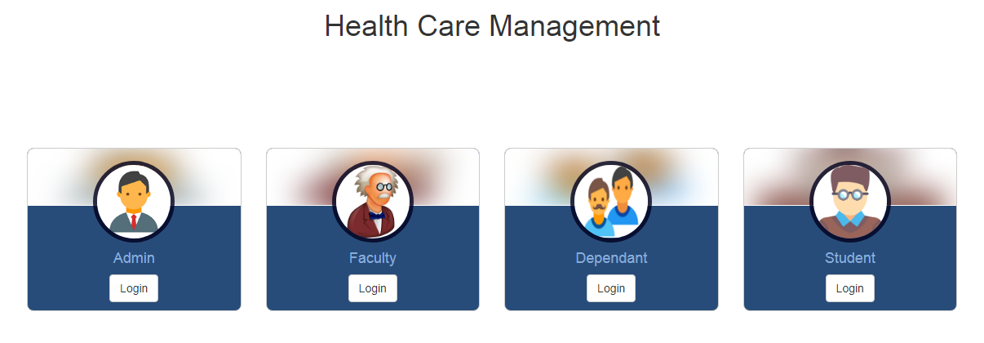

Figure 1.

**Admin Module:** In this project we are working on admin module. When we click on Admin as shown in (Figure 1.), we reach to this page where we have login screen (Figure 2.).

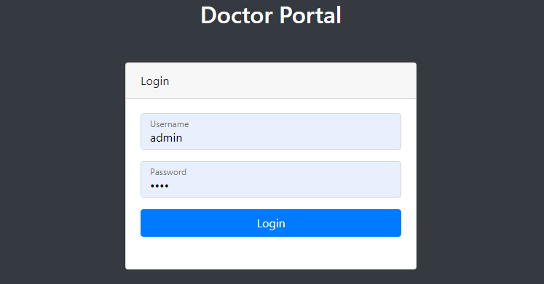

Figure 2.

**Admin Dashbord:**

In (Figure 3.) we have the Dashboard of admin module. The main purpose of this page is to allow only authorized users to view patient’s data or update the medication data. So, it provides the security to data from violation.

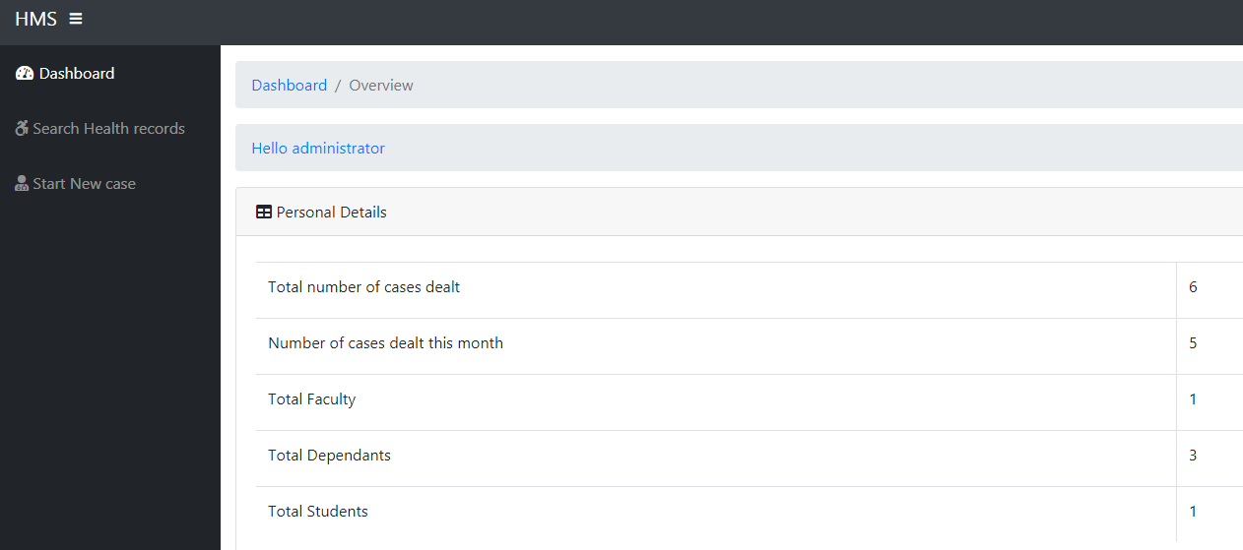

**Teacher Module:**

Figure 3.

Teacher module will have options to display previous medication of the faculty member. Faculty can also view his dependents list and can also add new dependent.

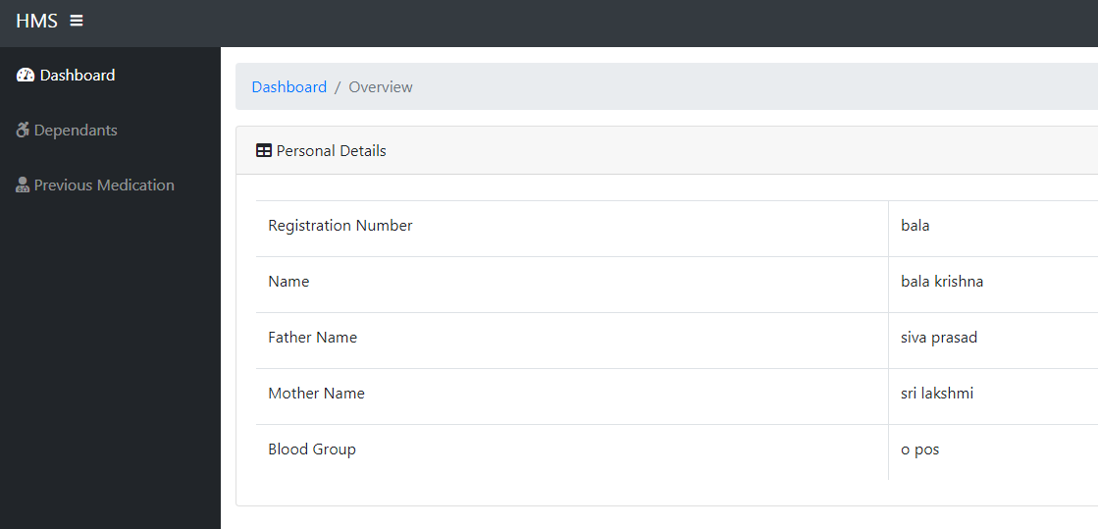

Figure 4.

**Dependent and Student Module:**

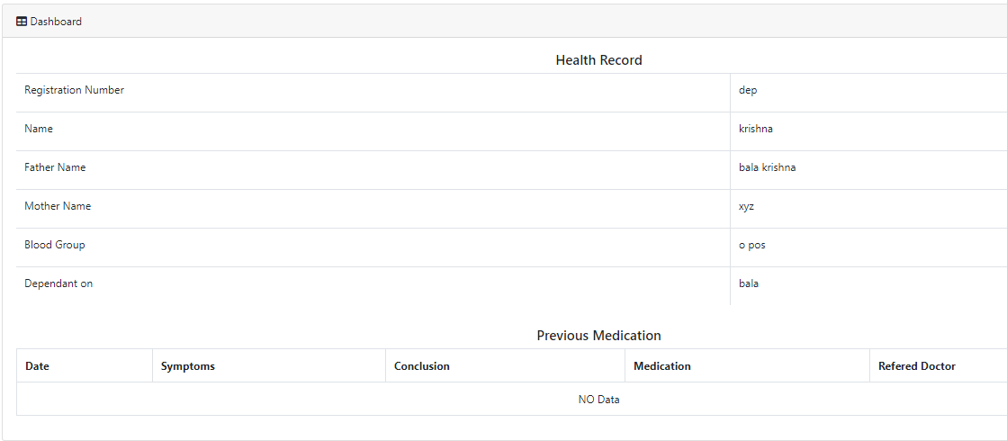

Figure 5.

In the (Figure 5.) we have the Dependent module dashboard. We can find the medical history of the user and personal info as well. The same will be displayed for Student dashboard also

# USE CASE DIAGRAM

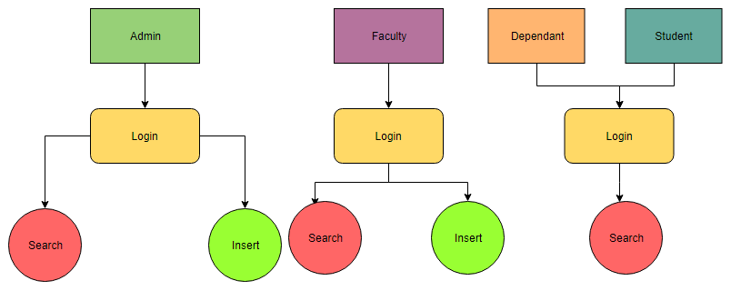

Figure 6.

This use case diagram portrays the actual working environment of the module. Here we can see the different users go to login the page and then they have access the data to perform different operations like insert, and search. Search operation is used to see the teacher record which we have searched. Insert operation is used to insert new data into the database.

# FLOW CHART

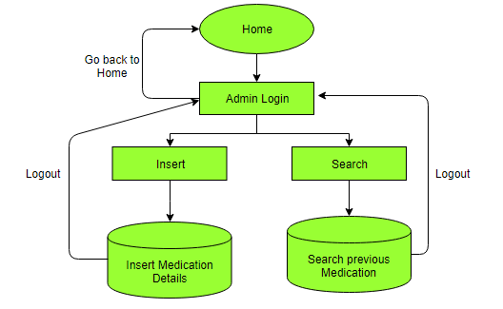

Figure 7.

The flowchart represents the step wise process of the project. We start from home page then we have selected the admin module to go to admin index page. The next level needs authorization. There we have to login with admin credentials. Up to this level we can go back to immediate previous page by simply clicking back option. Now in this case we can’t go back without logout action. Search page shows the search option to see the patient data. Insert page to insert medication details of patient. Double sided arrows show that the process is reversible.

# SOURCE CODE

The whole source code is available at: <https://github.com/thotakura2/health/>

# DATABASE TABLES

We have the following tables in our database:

* Admin
* Dependant
* Faculty
* Medication
* Users

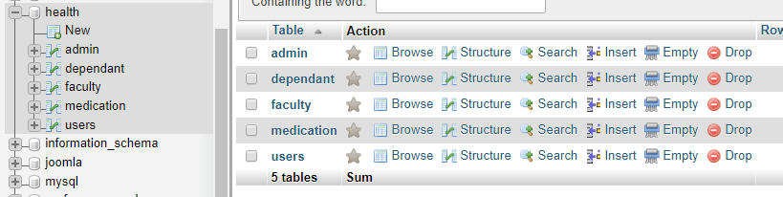

Figure 8.

**Record Table:**

Admin table will have the details of admin login like username password and name, from where we can authenticate admin. Dependant table will have the login and personal info of the dependants of faculty. Faculty table will have personal information of the faculty. Medication table will hold the medications of all the users. Finally, users table will have details of students.

# TESTING

Testing is performed to verify that the completed software package functions according to the expectations defined by the requirements/specifications. We have done two level of testing. First is unit testing and second is integration testing

**UNIT TESTING:** Unit testing is an action used to validate that separate units of source code remains working properly. We have checked by entering data in each field and all the queries are running properly. The results of all unit codes are reliable.

**INTEGRATION TESTING**: Integration Testing is a level of software testing where individual units are combined and tested as a group. The purpose of this level of testing is to expose faults in the interaction between integrated units. Test drivers and test stubs are used to assist in Integration Testing**.** We see that when testing performed there is no defect exposed in the interfaces and in the interactions between integrated components or systems.

# ADVANTAGES

Paper‐based, active records are managed in office locations where they are used. Over time the electronic formats of records will become more prevalent. The advantages of e-record over paper based record are following:

* Save employee(s) time in finding and accessing needed documents
* Easy to distribute documents throughout an organization and to the public if needed
* No more lost files
* Everyone is accessing the most current version of a document with the ability to see how a document changes over time
* Reduces paper records filing costs and makes it possible to move documents off-site freeing up valuable floor space
* Makes it possible to easily back-up documents in case of disaster (flood, fire, theft, etc…)
* Saves on wear and tear of paper records
* Increases the ability to securely store confidential document